VJWTSS08190012

BOOT CAMP DAY 2

MORNING

program 1:

Find the max and min value from a given array.

{10, 4, 5, 4, 8, 10}

Ans:

#include <stdio.h>

#define MAX_SIZE 100 // Maximum array size

int main()

{

int arr[MAX_SIZE];

int i, max, min, size;

/* Input size of the array */

printf("Enter size of the array: ");

scanf("%d", &size);

/* Input array elements */

printf("Enter elements in the array: ");

for(i=0; i<size; i++)

{

scanf("%d", &arr[i]);

}

/* Assume first element as maximum and minimum */

max = arr[0];

min = arr[0];

/*

* * Find maximum and minimum in all array elements.

* */

for(i=1; i<size; i++)

{

/* If current element is greater than max */

if(arr[i] > max)

{

max = arr[i];

}

/* If current element is smaller than min */

if(arr[i] < min)

{

min = arr[i];

}

}

/* Print maximum and minimum element */

printf("Max = %d\n", max);

printf("Min = %d\n", min);

return 0;

}

**Output:**

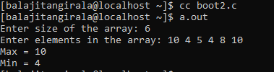

**Program 2**

5 different marks are stored for a student in an arry of size 10. Now, write code to insert a new assessment mark at an input position in the array and print the total marks before and after insert of the new mark.

**Ans:**

#include<stdio.h>

int main()

{

int marks[10];

int i,n,ass,sum=0,sum1=0;

printf("Enter marks:");

for(i=0;i<5;i++)

{

scanf("%d",&marks[i]);

sum+=marks[i];

}

printf("Enter new assessment marks\n");

scanf("%d",&ass);

printf("Enter a position\n");

scanf("%d",&n);

for(i=5;i>=(n-1);i--)

{

marks[i+1]=marks[i];

}

marks[n-1]=ass;

for(i=0;marks[i];i++)

sum1+=marks[i];

printf("before sum:%d \nafter sum:%d\n",sum,sum1);

for(i=0;marks[i];i++)

{

printf("%d ",marks[i]);

}

}

**Output:**

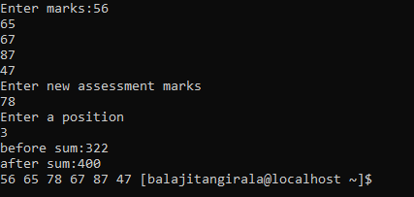

**Program 3:**

Given an array of numbers check whether the numbers are in ascending order?

**Ans:**

#include<stdio.h>

int main()

{

int n;

int arr[n],i;

printf("enter size of array");

scanf("%d",&n);

printf("enter the elements in a array:");

for(i=0;i<n;i++)

{

scanf("%d",&arr[i]);

}

for(i=0;i<n-1;i++)

{

if(arr[i]<arr[i+1])

{

printf("True");

break;

}

else

{

printf("False");

break;

}

}

}

**Output:**

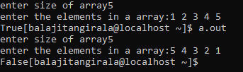

VJWTSS08190012

BOOT CAMP DAY 2

EVENING

**Program 4:**

An array contains n number of ids who have passed in an competitive exams . Write a c program to search an id in the array based on an input. If found   print "Congratulations….!", else print "Better luck next time"

**Ans :**

#include<stdio.h>

int main()

{

int i,d,c=0;

int arr[10]={ 1210,1211,1212,1213,1214,1215,1216,1217,1218,1219};

printf("Enter your ID:");

scanf("%d",&d);

for(i=0;arr[i];i++)

{

if(d==arr[i])

c++;

}

if(c==1)

printf("Congratulations.....!\n");

else

printf("Better luck next time\n");

}

**Output:**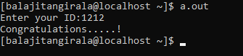

**Program 5:**

Write a program to Rotate an array of n elements to the right by k steps

**Ans:**

#include <stdio.h>

#define SIZE 10

void printArray(int arr[]);

void rotateByOne(int arr[]);

int main()

{

int i, N;

int arr[SIZE];

printf("Enter 10 elements array: ");

for(i=0; i<SIZE; i++)

{

scanf("%d", &arr[i]);

}

printf("Enter number of times to right rotate: ");

scanf("%d", &N);

N = N % SIZE;

for(i=1;i<=N;i++)

{

rotateByOne(arr);

}

printf("Array after rotation:\n");

printArray(arr);

return 0;

}

void rotateByOne(int arr[])

{

int i, last;

last = arr[SIZE - 1];

for(i=SIZE-1; i>0; i--)

{

arr[i] = arr[i - 1];

}

arr[0] = last;

}

void printArray(int arr[])

{

int i;

for(i=0; i<SIZE; i++)

{

printf("%d ", arr[i]);

}

}

**Output:**

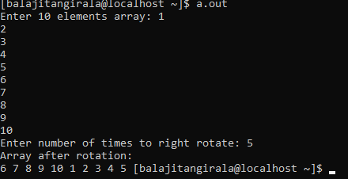

**Program 6 :**

Write a program which accepts number of Notes of Rs. 500,  
100, 50, 20, 10, 5 and 1 in an int array -First element  
correspond to Rs 500 number of notes etc. Find the total amount based on the information given.

{1, 0, 1,1,0,1,0}

**Ans :**

#include<stdio.h>

int main()

{

int note[7]={500,100,50,20,10,5,1};

int arr[7],i,total,res=0;

printf("enter how many notes:");

for(i=0;i<7;i++)

{

scanf("%d",&arr[i]);

}

for(i=0;i<7;i++)

{

total=note[i]*arr[i];

res=res+total;

total=0;

}

printf("%d\n",res);

return 0;

}

**Output:**

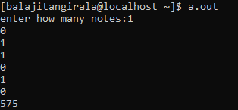

**Program 7:**

Write a c program to print an array of string in ascending order.

{"Suresh","Pranshu","Naveen","Ajay","Raj","Balaji"}

**Ans:**

#include<stdio.h>

#include<string.h>

int main(){

int i,j,count;

char str[25][25],temp[25];

puts("How many strings u are going to enter?: ");

scanf("%d",&count);

puts("Enter Strings one by one: ");

for(i=0;i<=count;i++)

gets(str[i]);

for(i=0;i<=count;i++)

for(j=i+1;j<=count;j++){

if(strcmp(str[i],str[j])>0){

strcpy(temp,str[i]);

strcpy(str[i],str[j]);

strcpy(str[j],temp);

}

}

printf("Order of Sorted Strings:");

for(i=0;i<=count;i++)

puts(str[i]);

return 0;

}

**Output:**

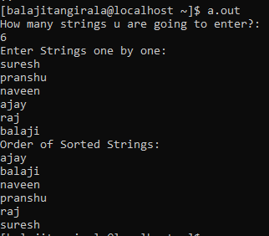

**Program 8:**

Find the intersection elements of two given arrays.

a = {10, 4, 5, 8, 6}  
b= {9, 5, 4, 7, 11}

**Ans :**

#include <stdio.h>

int main()

{

int a[10], b[10], flag = 0, n1, n2, i, j;

printf("Enter array a size : ");

scanf("%d",&n1);

printf("\nEnter array b size : ");

scanf("%d",&n2);

printf("\nEnter array a element : ");

for(i = 0;i < n1;i++)

scanf("%d",&a[i]);

printf("\nEnter array b element : ");

for(i = 0;i < n2;i++)

scanf("%d",&b[i]);

printf("Intersection: ");

for(i = 0;i < n1;i++)

{

for(j = 0;j < n2;j++)

{

if(b[i] == a[j])

{

flag = 1;

}

}

if(flag == 1)

{

printf("%d ", b[i]);

}

flag = 0;

}

return 0;

}

**Output :** 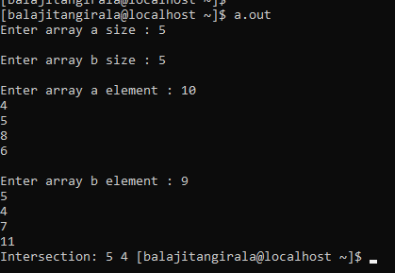

**Program 9:**

A board game contains a 2D array of 4x4. The program accepts a sequence of commands (LEFT/RIGHT/UP/DOWN). Starting point (x,y) is also given by the user. Find the final position based on the sequence of commands.\

Start position = (1,2)  
Commands = {"LEFT", "UP", "RIGHT", "UP", "RIGHT"}

**Ans :**

**Output:**

**Program 10:**

Consider the input in input column and produce the output given in the ouput column.

      2       5        3           
4      
2      
1

**Ans :**

#include<stdio.h>

int main()

{

int a[3]={2,5,3},b[3]={4 ,2,1},i,j;

for(i=0;i<3;i++)

{

printf("\t%d ",a[i]);

}

for(i=0;i<3;i++)

{

printf("\n%d\n",b[i]);

for(j=0;j<3;j++)

{

printf("\t%d ",a[j]*b[i]);

}

printf("\n");

}

return 0;

getch();

}

**Output:**

